Team Work Division (6 Members)

PHASE 1: Setup, Strategy & Prompt Engineering
- Task 1: Investment Strategy & Macro Background (2 Members)
  - Responsibilities: Define the strategic placement for SPIF (e.g., sector-specific, regional, or rating-focused), write the macroeconomic justification, and finalize the list of at least 20 target companies from the MSCI Global universe.
- Task 2: AI Extraction Prompt Engineering & AI Usage Log (1 Member)
  - Responsibilities: Build and refine the step-by-step extraction instructions for our AI agent (covering financial statements, discount rate components, and valuation inputs). Manage, format, and keep track of the mandatory AI usage log (.txt, .json, or .jsonl).

PHASE 2: Execution, Valuation & Presentation
- Task 3: Company Overview, Strategy Alignment & Fundamentals (2 Members)
  - Responsibilities: For each assigned company, write the company description, evaluate its business model under the chosen strategy, and gather historical financial statement data using our structured AI prompts.
- Task 4: Valuation Models (DCF & Relative Multiples) & Recommendations (2 Members - can overlap with Task 3)
  - Responsibilities: Build the DCF models (including WACC calculation, cash flow projections, and sensitivity analysis), apply appropriate market multiples (Relative Valuation), reconcile the values to determine Fair Value, and formulate final investment recommendations (Buy, Hold, Sell).
- Task 5: PPT Presentation Design (Max 15 Slides) & Appendix Compilation (1 Member - Cross-functional/Rotation)
  - Responsibilities: Design the final 15-slide structure for top management, ensuring visual appeal, alignment with the narrative, and compliance with the 15-slide limit. Aggregate all detailed calculation worksheets into the Appendix.

Company introduction + logo. Date of the evaluation, currency, last annual report date (for example 31 set or 31 dic). Annual report used: ALWAYS Consolidated annual report

- STEP 1: Debt ratio. = D/(D+E)
In the instruction of the group project there are suggested link from the professor.
HOW TO FIND E?
For MKT Value of Equity use: https://global.morningstar.com/fr (insert the ISIN/Ticker of company in the tab of research) and look for mkt cap or compute this formula P/E=nX --> mkt cap = nX*E
NB: when you search the company you find data from different markets, take the ones where the company is listed (for example this one is listed in portugal)
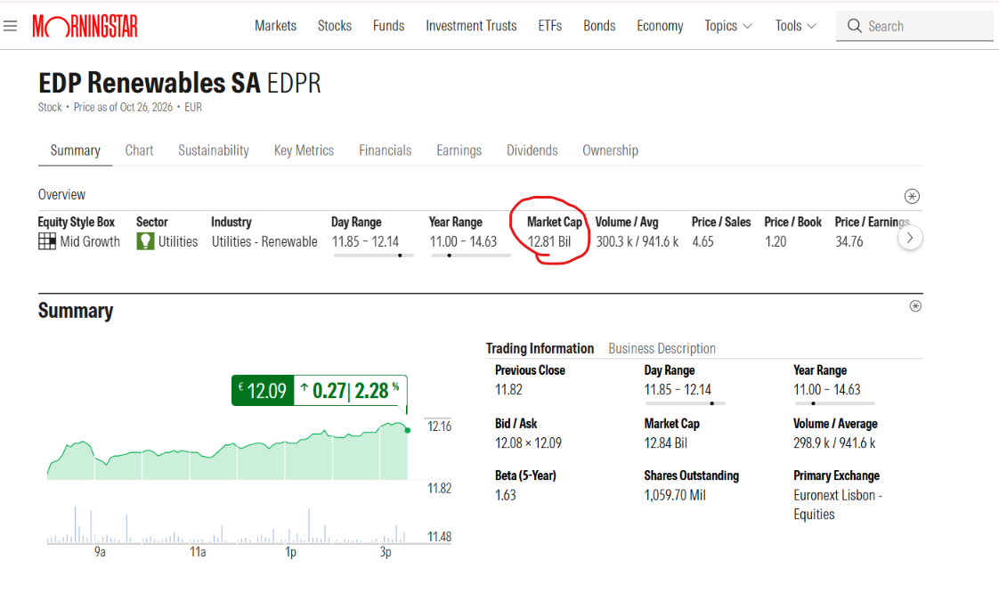
Compare it with the book values of Debt and Equity from the annual report over the last five years.
HOW TO FIND THE D?
Option 1 (preferred): Use the fair value, if available, and compare it with the Damodaran value.
Option 2: Take the average of the book value and the Damodaran industry value. Market Debt / (Debt + Equity) – (https://pages.stern.nyu.edu/~adamodar/pc/datasets/dbtfundEurope.xls)
Option 3: Take the value estimated from data vendors like Bloomberg and compare with Damodaran and average book value.
Option 4: If bonds represent a marginal portion, the book value of debt is valid.



- STEP 2: WHICH TYPE OF CASH FLOW TO USE?
Considering that we're not taking into account neither banks nor funds, we can exclude dividends and the two options are FCFF or FCFE.
- If the δ = D/(D + E) is stable over the years we choose FCFE
- If the δ = D/(D + E) is not stable over the years we choose FCFF
FCFF = EBIT*(1-tax) - (CAPEX –D&A) - Change NWC
FCFE = NI - (CAPEX –D&A) - Change NWC - (Debt repaid – New Debt)
- EBIT = operating profit_{adj} (annual report) (use the adjusted, not the one in the IS/P&L) à trailing à EBIT_{adj} = EBIT_{2025 adj} – EBIT_{Q1 2025} + EBIT_{Q1 2026}
- NI = net earnings_{adj} (annual report) (use the adjusted, not the one in the IS/P&L) à trailing à NI_{adj} = NI_{2025 adj} – NI_{Q1 2025} + NI_{Q1 2026}
N.B. Use adjusted EBIT directly as the operating profit measure, and specify how it differs from reported EBIT. List each adjustment that reconciles the two figures (e.g., restructuring costs, impairments, gains or losses on disposals), taking the amounts from the company’s own reconciliation in the annual report.
NI we need to consider the net income from the group (NOT just the net income attributable to shareholders/owners of the parent)
- Tax rate = taxes / earnings before taxes (IS/P&L). (We obtain the effective tax rate and we compare it with previous years values to understand if it is stable. After it we compare it with the tax rate of the country, so the marginal tax rate)

- NET CAPITAL EXPENDITURE_{t} = CAPEX* - D&A cons
- NET CAPITAL EXPENDITURE_{t-1} = CAPEX* - D&A cons
- NET CAPITAL EXPENDITURE / EBIT (1-Tax) from Damodaram (https://pages.stern.nyu.edu/~adamodar/pc/datasets/capexEurope.xls) (which industry?)

Calculate Net Capital Expenditure (NCE) for the current year and the previous year as CapEx minus consolidated D&A. Include intangible assets as well as property, plant and equipment in CapEx. Before including each item, assess whether it is likely to recur in the future, and compare it with previous years to understand the trend. Include an item only if it is part of the company’s business model and recurs over time; otherwise exclude it from the DCF. For example, for Nestlé business acquisitions should be included, because acquiring businesses is a recurring part of its growth strategy.
Then calculate NCE / EBIT(1−t) for both years and compare these ratios with the Damodaran industry average (European dataset, choosing the industry that best matches the company’s business, e.g., Food Processing for Nestlé). Select a single percentage within the range of these values. Do not simply take the average: give more weight to years without significant one-off items such as write-offs or impairments, and briefly justify the choice. Apply the selected percentage to EBIT(1−t) to project NCE.
Do not apply R&D capitalisation or lease adjustments. Keep EBIT, CapEx and D&A consistent with the adjusted EBIT taken from the annual report. Use the same definitions and scope: if an item (e.g., impairments or write-offs) is excluded from adjusted EBIT, exclude it from D&A in the NCE calculation as well.
- NET WORKING CAPITAL = (current assets – cash and cash equivalents) - (current liabilities – current financial debt)
- ΔNWC* = NWC_{t} – NWC_{t-1}
- NWC/SALES MULTIPLE on Damodaram (https://pages.stern.nyu.edu/~adamodar/pc/datasets/wcdataEurope.xls) (which industry?)
Calculate the company’s NWC/Sales ratio for the current year and the previous year, and compare these values with the Damodaran industry average NWC/Sales (European dataset, choosing the industry that best matches the company’s business, e.g., Food Processing for Nestlé). Use the comparison to understand the trend. Then select a single NWC/Sales percentage that lies within the range of these values: take the average of the company’s ratio and the Damodaran industry average, and briefly justify the choice.
If ΔNWC (NWC_t − NWC_t-1) is negative, set it to 0 in the cash flow projections. A negative ΔNWC means working capital releases cash and increases free cash flow; setting it to zero is the more conservative choice and avoids overstating the valuation.

- STEP 3: GROWTH FORMULA and REINVESTMENT RATE
First stage of growth:
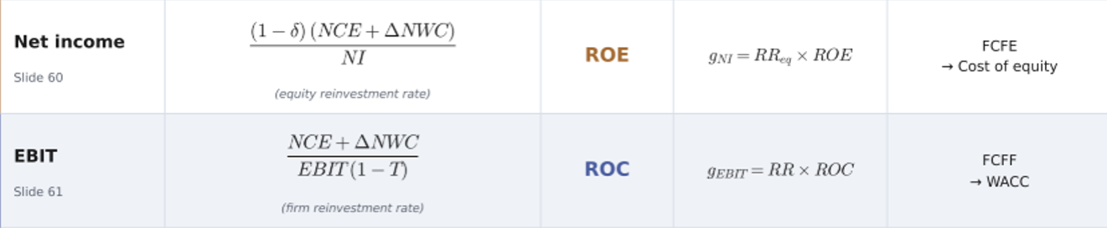
ROE = Net income / Equity_{t-1}
ROC = EBIT(1-T) / (D_{t-1}+E_{t-1}-CASH_{t-1})
ROC = EBIT(1-T) / (D_{t-1}+E_{t-1}+Mi_{t-1)}
N.B. As Ebit and Net income we consider the adjusted and trailing values that we found before
Decide the time period over the first stage (3 or 5??) and a threshold for the second stage of growth linked to inflation.
- STEP 4: DISCOUNT RATE
- the FCFE is discounted with the K_{e}
- the FCFF is discounted with the WACC
COST OF EQUITY The Three Approaches — Formulas & Assumptions
The only thing that changes is what goes into the ERP bracket.
CRPà The additional premium demanded for holding stocks in a risky/emerging country vs. a mature market. It's the "extra layer" of risk on top of the base.
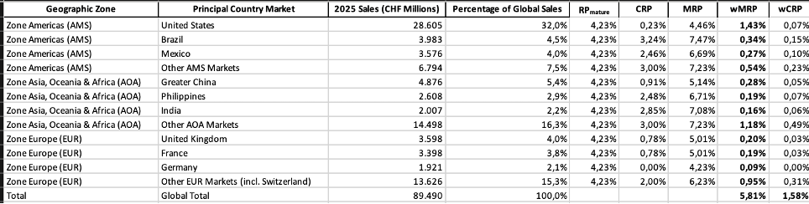
Country Risk Premium (CRP). Take the CRP from Damodaran’s country risk table (https://pages.stern.nyu.edu/~adamodar/New_Home_Page/datafile/ctryprem.html), using the column “Country Risk Premium”. Do not use “Adj. Default Spread”, which is the raw sovereign default spread before the equity volatility adjustment. Do not use “Equity Risk Premium” either, which already includes the mature market premium (4.23%) and would count it twice.
Weighted CRP for multinational companies. If the company operates in more than one country, compute a revenue-weighted average CRP, using each country’s share of total revenues as the weight:
Weighted CRP = Σ (Revenues in country i / Total revenues) × CRP of country i
Take the revenue breakdown by country or geographic area from the company’s annual report (segment or geographic sales disclosure). For aggregated areas that are not single countries (e.g., “Other AMS markets”), use the corresponding regional average CRP from Damodaran’s downloadable Excel file (ctryprem.xlsx), and state the choice.
The equity risk premium used in the cost of equity is then: ERP = Mature market ERP + Weighted CRP.
RPà Risk premium mature country= Equity Risk Premium - Country Risk Premium. You can directly consider it 4.23 as a result of the equation starting from the value of Damodaram (Link: https://pages.stern.nyu.edu/~adamodar/New_Home_Page/datafile/ctryprem.html)
Cost of equity with country risk – three models
There are three ways to include country risk in the cost of equity. They differ in how the company’s exposure to country risk is measured. All three use the same inputs (risk-free rate, beta, mature market equity risk premium and country risk premium); only the way they are combined changes.
Approach 1 – “Everyone gets the full CRP” (recommended)
R = Rf + CRP + β × ERP_mature
Assumption: country risk is added as a flat premium on top of the standard CAPM, regardless of the company’s beta.
Limitation: applied with a single country’s CRP, it treats every firm in that country the same way, whether it is a large multinational or a small local business.
Why we use it: we apply it with the revenue-weighted CRP computed from the company’s geographic sales breakdown. The CRP therefore already reflects the company’s actual exposure to each market, which removes the main limitation. The approach stays simple, transparent and easy to justify.
Approach 2 – “Country risk scales with beta”
R = Rf + β × (CRP + ERP_mature)
Assumption: exposure to country risk is proportional to exposure to market risk. A high-beta firm (e.g., a cyclical company with β = 1.5) is more exposed to country risk; a defensive firm (β = 0.6) is less exposed.
Strength: it is Damodaran’s default approach and a reasonable middle ground for most companies.
Limitation: it fails when the company’s revenue mix is very different from the country average, for example a multinational earning most of its revenues abroad. In those cases it over-penalises the company.
Approach 3 – “Lambda” (firm-specific exposure)
R = Rf + β × ERP_mature + λ × CRP
Assumption: country risk is a separate risk factor, distinct from market risk. Each company has its own sensitivity to it (λ), independent of beta.
Estimating λ (revenue approach): λ = % of the company’s revenues in country X / % of revenues the average firm in country X earns there. λ ≈ 1 is a typical local firm; λ < 1 is a multinational with global sales; λ > 1 is a firm concentrated on its domestic market.
When to use: companies earning most of their revenues outside their home market, typically emerging-market multinationals. Use it only as a cross-check here, because data on the average firm’s revenue share is hard to obtain.
Where to find each input
Risk-free rate (Rf): yield on the 10-year government bond in the same currency as the cash flows (for CHF cash flows, the 10-year Swiss Confederation bond). Sources: the central bank website (e.g., Swiss National Bank), Bloomberg or investing.com. If the government is not rated Aaa, subtract its default spread (“Adj. Default Spread” in Damodaran’s ctryprem.html) to obtain a true risk-free rate.
Beta (β): either the regression beta from Bloomberg, Refinitiv or Yahoo Finance (state the index, period and frequency used), or Damodaran’s industry unlevered beta from betaEurope.xls (“Unlevered beta corrected for cash”), relevered with the company’s market D/E: βL = βU × [1 + (1 − t) × D/E].
Mature market ERP (ERP_mature): from Damodaran’s ctryprem.html. It equals the “Equity Risk Premium” of any Aaa country, e.g., Germany or Switzerland: 4.23% (January 2026 update). Do not use the US figure (4.46%), because it already includes the US country risk premium.
Country risk premium (CRP): the “Country Risk Premium” column in ctryprem.html. For a multinational, compute the revenue-weighted average using the geographic sales breakdown in the annual report, as described in the previous section.
Lambda (λ): the company’s revenue share by country from the annual report (geographic sales disclosure). For the average firm’s revenue share, use Damodaran’s country risk paper or the domestic revenue share of comparable peers from their annual reports.

Cost of debt (Kd): objective and formula
Kd is the pre-tax rate the company would pay today to borrow long-term. It is built from two separate components that must not be confused:
Kd = Rf + Company Default Spread
Rf = 10Y government bond yield − Sovereign Default Spread
After-tax Kd (used in the WACC) = Kd × (1 − t)
Sovereign Default Spread = CRP (Country Risk Premium) in this file
https://pages.stern.nyu.edu/~adamodar/New_Home_Page/datafile/ctryprem.html

- The Sovereign Default Spread (country DRP) refers to the country that issues the currency of the cash flows. It is only used to clean the government bond yield, so that Rf is truly risk-free.
- The Company Default Spread refers to the company’s own credit risk. It is the extra return lenders require because the company might not repay.
Step 1 – Risk-free rate (Rf)
- Identify the currency of the cash flows and take the 10Y government bond yield in that currency (central bank website, Bloomberg or investing.com). Use the 10Y German Bund for EUR, the 10Y Swiss Confederation bond for CHF, the 10Y Gilt for GBP and the 10Y US Treasury for USD.
- Look at the historical chart of the yield. If the current value is clearly anomalous compared with the past, use a normalised value and justify the assumption.
- Check the Moody’s rating of the issuing country in Damodaran’s ctryprem.html.
  - If it is Aaa (e.g., Germany, Switzerland, Sweden, Denmark, Norway), Rf = government bond yield.
  - If it is below Aaa, subtract the sovereign default spread Rf = Yield Bond – default spread country (“Adj. Default Spread” column in ctryprem.html, or the sovereign CDS spread on Bloomberg). Examples: USD, Rf = 10Y Treasury − 0.23% (US rated Aa1); GBP, Rf = 10Y Gilt − 0.51% (UK rated Aa3); JPY, Rf = 10Y JGB − 0.60% (Japan rated A1).

Step 2 – Company Default Spread
Use the first option available:
- Actual credit rating of the company (S&P, Moody’s or Fitch, shown on the investor relations page). Convert it into a spread with Damodaran’s rating/spread table (ratings.html), using the large-firm table for large caps.
- Synthetic rating if the company is not rated. Compute the interest coverage ratio (EBIT / interest expense) from the annual report and map it to a rating and spread with the same table.
- Market check: compare the result with the yield to maturity of the company’s long-term bonds minus Rf, or with the company’s CDS spread (Bloomberg). If the market spread differs significantly from the rating-based spread, comment on it.

Step 3 – Country risk in the cost of debt (only if relevant)
Assess whether the company's cost of debt should include an additional country default spread based on its size, geographic diversification, and revenue exposure to countries with sovereign default risk (rated below Aaa).
- Small companies with geographically concentrated revenues: If the company generates most of its revenues in a country with significant sovereign default risk, add a country risk adjustment to Kd. Estimate the adjustment by multiplying the percentage of revenues generated in that country by its sovereign default spread (Revenues in that Country/Total Revenue * CRP)
- Large, geographically diversified companies: If the company operates globally and generates revenues across multiple countries, with no significant concentration in a risky market, ignore the additional country default spread.
Formula (when applicable):
Weighted Country Default Spread = Σ (Revenues in country i / Total revenues) × Default Spread of country i
Kd = Rf + Weighted Country Default Spread + Company Default Spread
Data sources:
- Country default spreads: Damodaran's Country Risk Premiums dataset, using the “Country Risk Premium” column (not the equity risk premium).
- Geographic revenue breakdown: Company's latest consolidated annual report.
Instructions for the valuation:
- Determine the company's size and geographic revenue distribution.
- Identify countries with material sovereign default risk.
- Decide whether the adjustment should be fully applied, partially applied, or ignored.
- Calculate the adjustment when applicable and incorporate it into Kd.
- Explicitly document and justify the decision, including the selected coefficient, the underlying revenue exposure, and the data sources used.
Do not automatically add country risk solely because the company operates in a country rated below Aaa. The adjustment must reflect its actual exposure and geographic diversification. Avoid double counting sovereign risk if it is already reflected in the company default spread derived from an actual credit rating.

Step 4 – Tax rate and after-tax Kd
Use the marginal corporate tax rate (“Corporate Tax Rate” column in ctryprem.html) of the company’s home country, or a revenue-weighted rate if activity is spread across many countries. State which one is used. Then compute after-tax Kd = Kd × (1 − t).
Consistency Checks
-Currency Consistency: Cash flows and discount rates must be expressed in the same currency.
-Inflation Consistency: Cash flows and discount rates must be consistent in nominal or real terms. If cash flows include expected inflation (nominal cash flows), the discount rate must also incorporate inflation (nominal discount rate). Conversely, real cash flows must be discounted using a real discount rate.
-Risk-Free Rate Consistency: The same risk-free rate (Rf) must be used to estimate both the Cost of Debt and the Cost of Equity.
-Transparency of Inputs: Each component (government bond yield, sovereign spread, risk-free rate, company spread, cost of debt, tax rate and after-tax cost of debt) must be reported separately, together with its respective source.
Beta (levered)
Use a bottom-up beta as the base case.
- Unlevered beta (βu): take the industry average from Damodaran’s beta dataset (betaEurope.xls, or the global file for multinationals), column “Unlevered beta corrected for cash”, for the industry that best matches the company (e.g., Food Processing for Nestlé). If the company operates in several businesses, use a revenue-weighted average of the industry βu.
- D/E: use market values, consistent with the WACC weights and with the Debt ratio calculated at the beginning. E = market capitalisation (share price × shares outstanding, from the stock exchange or Bloomberg). D = market value of debt (fair value from the annual report notes if available, otherwise use the other methods as defined in the debt section).
- Tax rate (t): use the same marginal tax rate used for the after-tax cost of debt and for the FCF, for consistency. If the effective tax rate is used instead, state it and justify why.
- Relever: βl = βu × [1 + (1 − t) × D/E]
Regression beta (cross-check only): take the company’s regression beta from Bloomberg, Refinitiv or Yahoo Finance. State the index (a broad global index such as MSCI World for multinationals), the period and the frequency (e.g., 2 years weekly or 5 years monthly). Compare it with the bottom-up beta and comment on any large difference. Do not use it as the base case: a single-company regression has a high standard error and reflects the past capital structure.
Weighted Average Cost of Capital (WACC)
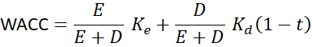
Two reminders emphasised in class:
- Use market values of debt and equity, not book values.
- Consistency again: WACC discounts FCFF and gives Enterprise Value.

NOTES:
- if I say “previous years values, I want you to go over the last five years to understand the trend)
- if I write “t” I mean for year 2025, if I say “t-1” I mean for the year 2024
- Ke means cost of equity, Kd cost of debt, wacc weighted average cost of capital
- Tax rate is written in two ways, as T and as tax

Alcune cose che mancano:
- Se ho usato il FCFF allora trovo il MV firm quindi come tornare al MV equity ?

- How to evaluate the WACC if there are COCOBOND / different types of share
so you don’t know D/E (PAG 88)

